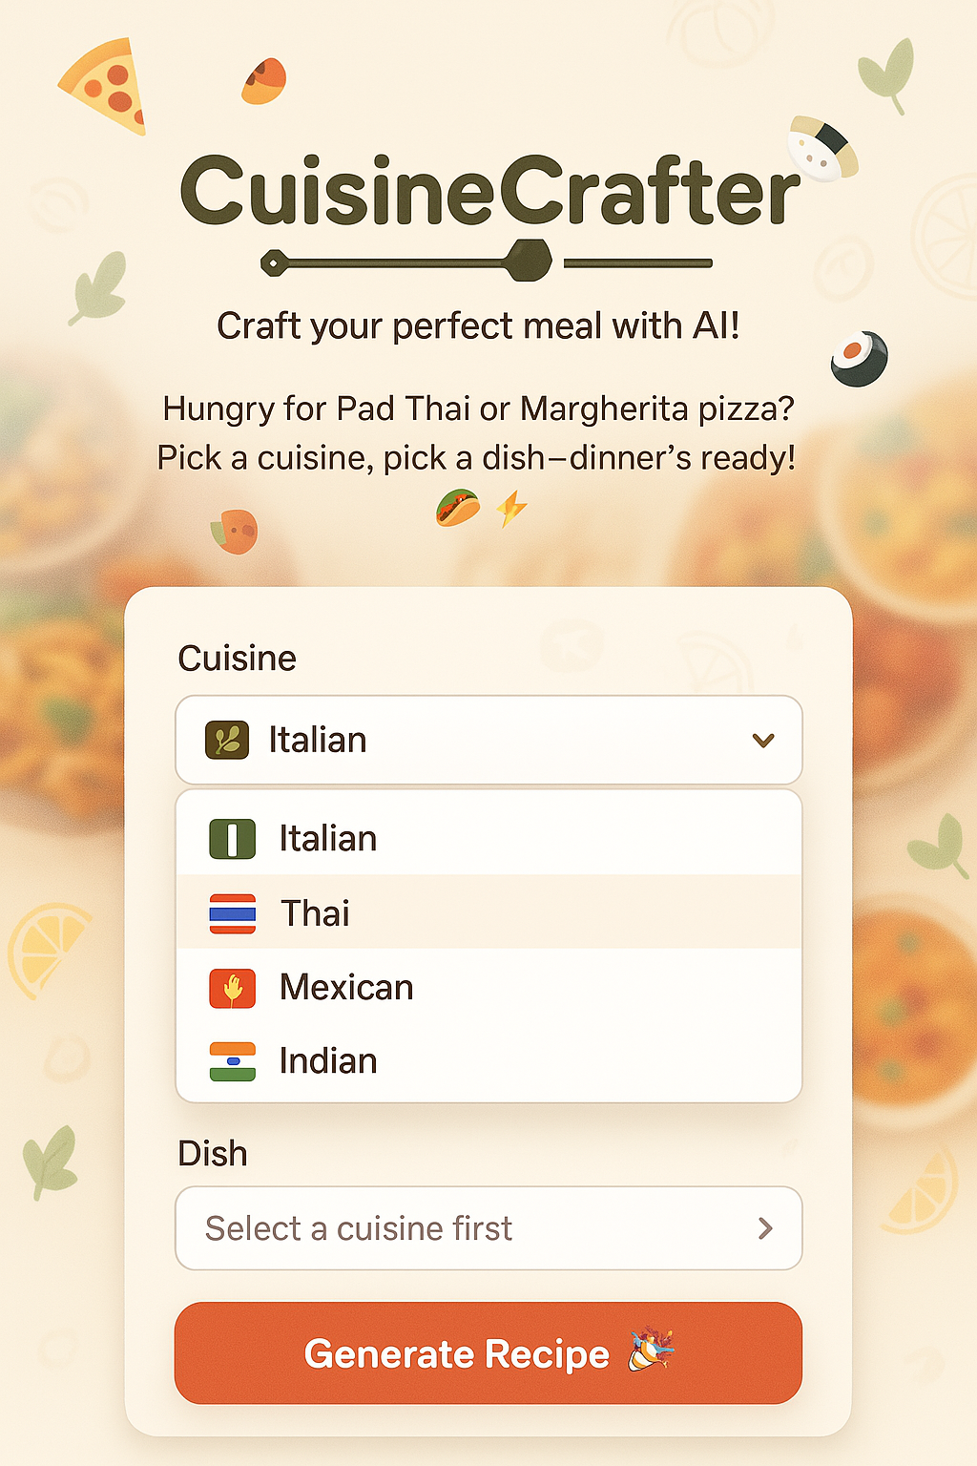  
Pre-Requisite:

* Following API keys/Tokens are required to execute the flow:
  + Groq
  + Astra DB Application Token
* Create Vector DB in AstraDB.
  + Database Name: Cuisines
  + Collection Name: recipes
  + Embedding Model or Astra Vectorize: Astra Vectorize
* Add the following documents to Vector DB by running the RAG flow
  + ItalianRecipe.pdf
  + MexicanRecipe.pdf
  + ThaiRecipe.pdf
  + IndianRecipe.pdf
* Following prompt should be passed to the Langflow API to execute this flow”
  + *Share the recipe to make following {Cuisine} dish: {Dish}*
  + *Cuisine* and *Dish* are variables selected by the user from UI